Manufacturers > Cars > Ford-Passenger > Escort > RS2000

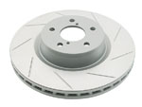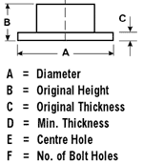 | Ford-Passenger Escort RS2000  Top of Form  Bottom of Form
  Category: | Disc Rotor
  Code: | DBA118S
  Year(s): | All
  Application:
  Brand: | DBA Slotted (pair)
  Solid/Ventilated: | Solid
  Price: | $275.00
  Disc Rotor Dimensions
  A | B | C | D | E | F
  247 | 26.5 | 12.5 | 11.4 | 68 | 4

Manufacturers > Cars > Ford-Passenger > Laser > KE

Ford-Passenger Laser KE
Category: | Disc Rotor
Code: | DBA101S
Year(s): | Turbo
Application:
Brand: | DBA Slotted (pair)
Solid/Ventilated: | Vented
Price: | $302.50

Disc Rotor Dimensions
A | B | C | D | E | F
260 | 32 | 18 | 16 | 75 | 4
Top of Form

Bottom of Form

DBA679SL
.RRP$275.52 ea (AUD)
Street Series Slotted Left-Hand Front Vented
- Ideal for towing and heavy load driving
- Ideal in heavy braking situations
- Performs well in wet conditions
- Looks great behind open style alloy wheels
- Rapidly expels friction gases and minimises brake fade
- Direct fit replacement part no modifications required

Part dimensional details
  Product Weight: 5 kg
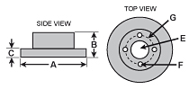
   | A | B | C | D | E | F | G
  Units | Dia. | Height | Thick | Min.Thick | Centre  Hole | # of Bolt Holes | P.C.D.
  mm | 260 | 35.1 | 22 | 20.4 | 66 | 4 | 100
  inch | 10.24 | 1.38 | 0.87 | 0.8 | 2.6 | 4 | 3.94

