Please take 5 minutes to read this, as it will have you finishing my car in no time!!!!!
- My car doesn’t have a crank angle sensor, you may be getting confused with the Hall Effect sensor in the dizzy. This isn’t a ‘crank angle sensor’

- Check the Pull UP resistor (and the 12v), must check these before considering giving up on ignition control.

- If there is no RPM signal then the wring is wrong, need to check this

- You should really RTFM, its not that hard to do, it isn’t reinventing the wheel it has been done many times before and is spelled out on how to do it on the site IN THE MANUALS (the MSnS site/manual for ignition control)

- Ok, on the dizzy there are 3 wires. They are labeled on the top of the black plug socket -, + and 0. Here is where they go;
left: - Earth. Either the body of the car or pin 7-11 or 19 on MS
Middle: 0 signal. Goes straight through to pin 24 on MS. It will also need a pull up resistor. That means a 1k ohm resistor attached somewhere on the 0 wire and to 12 volts (pin 28 or coil +).
Right: +5V. Connect though a 10 ohm resistor to pin 26.
This is a picture to illustrate it;
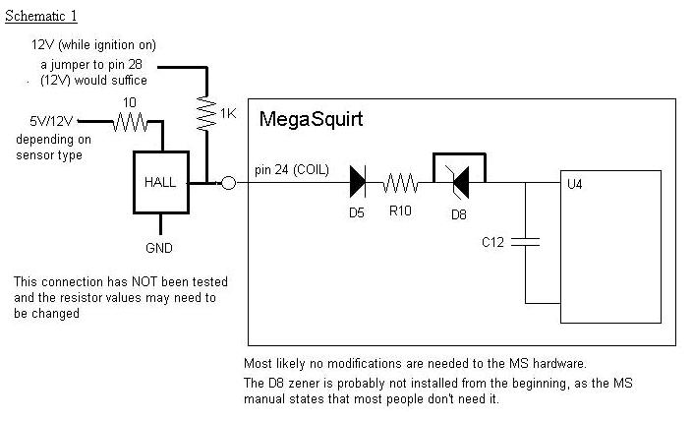

- Now pop off the top off the Mega Squirt box and check visually that the Hall/Option circuit has been installed (it should be). I have added another page with what to look for, titled “ TO INSTALL THE HALL/OPTICAL CIRCUIT). The names (R1, R2, Q1, Q2 etc) are printed on the circuit board. Attached is a board layout with where it is, and what should or not be there so you can visually check in 5 seconds! also incase you don’t know what a jumper is it is a piece of wire, any wire is fine.

- While you are there, check the idle transistor. Try and read what is written on them both and that will tell you if it has been done. If it is small and black or silver then it probably hasn’t. If there’s one that’s larger, flat and black attached to that spot with wires he probably has.

- This should get you going!!!! The dizzy needs to be timed but I hope you would be able to do that in your sleep! Then you can load MSQ. ALSO if you get RPM signal in megatune but still wont start check the TIMING.

- The car has now been IN boostworx for roughly 17 working weeks so that’s 87 days that it has been there, so take away public holidays etc so roughly 80 days. Lets do some more math’s……that’s 640 possible hours that was there for the taking. OK I know you own a reputable business and you have other cars that may come in and have priority but when a car has been in a work shop for over 80 days when it was agreed on when first arriving it would only be in there for 9 I feel that it should have a lot of priority in the shed. I am a fulltime Student at Tafe while also holding down a part time job to try and fund all this “work” being done. For me to have my car away for this long is a great load on me and my family as I have a younger brother I am required to drive around. Also recently I was involved in a car accident in the 2nd of the remaining family cars. This car is now a write off and we are left with a family of 4, 3 of those licensed drivers with only 1 car. So I hope you can understand my urgency in getting my car back!
Regards
Rhys Hillman

